
CO2-W-TH-POE

CO2 Sensor with Temperature & Humidity
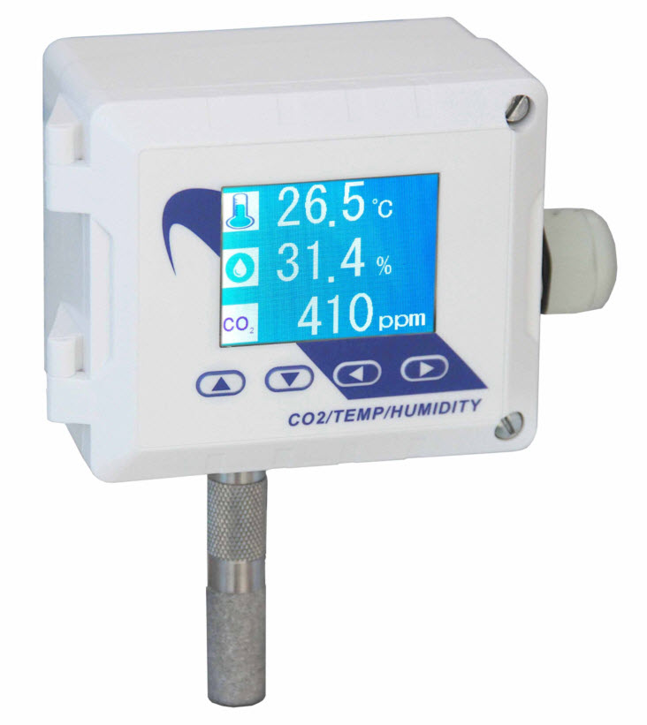
& BACnet & Power Over Ethernet

GOTCHAS
11 April 2023

Power and Physical Connections

- Requires IEEE 802.3af/at compliant POE Injector (54 Volts)
  - specification sheet says 24 volts, but will not work with Passive POE standard (24 volts).
- Ethernet Cable CAT6 (or better) with 1/2” bend radius to exit device
- Should also be able to power with standard 24 Volt supply instead of POE

Boot-up

- 15 second boot-up: 11 second flashing white screen followed solid white screen

Ethernet

- Design does not respond to Network Command “ipconfig”
- Should respond to “ping ip address”

