Preparing Your Computer
Setting a Static IP Address on your Computer
For all of the device models discussed below you will be asked to set a static IP address on your computer as part of the install process. Various computer operating systems have different ways of accomplishing this, and there is a wealth of information in computer manuals, publications, and online resources to walk you through the steps for your specific computer.
As mentioned above, AREDN® recommends that you connect your computer to the node through an intermediary network switch. This allows your computer to activate its Ethernet interface with the static IP address even when the node is not powered on. Since node hardware needs to be powered on/off or rebooted during the install process, the network switch will keep your computer’s network interface active on its static IP address.
If you choose not to use an intermediary network switch, then you will be responsible for making sure your computer maintains an active interface with the static IP address. You may need to power on the node temporarily in order for your computer to bring up its interface, but then immediately power off the node in order to follow the installation instructions for your model. Having an intermediary network switch eliminates these headaches.

Depending on your device model you may need to have various command line tools available on your computer. The required tools are native to both Linux and MacOS computers. For Windows computers you may need to enable specific features or install appropriate programs.
Mikrotik and TP-LINK Installs
These devices are programmed to download a boot image from an external source. Your computer can run a PXE server which can give the node an IP address via DHCP as well as providing the firmware image via TFTP.
If you have a Windows computer you will need to install and configure a PXE server. The examples below use Tiny PXE which can be downloaded from erwan.labalec.fr. There may be other alternative Windows programs that accomplish the same goal, such as ERPXE or Serva. For TP-LINK devices you may be able to run a simple TFTP server such as Tftpd64 as explained in the TP-LINK section below.

PXE Server
If you are using a PXE server to provide your device with an IP address and a new firmware image, be sure to allow the PXE server through your computer’s firewall. If the PXE server does not display any activity when you begin your firmware install, check your firewall settings. On the Windows control panel, for example, click Advanced Settings and look through the “Inbound Rules” to see if a rule exists for the PXE server. If a rule exists, make sure to “allow connection” for both private and public networks. If no rule exists, create a new rule allowing connection for both public and private networks.

Mikrotik First Install Process
Mikrotik devices require a two-part install process: First, boot the correct Mikrotik initramfs-kernel file, and then use that temporary AREDN® Administration environment to complete the installation of the appropriate sysupgrade file.
Mikrotik devices have a built-in PXE client which allows them to download a boot image from an external source. You will need to install and configure a PXE server on your Windows computer. The example below uses Tiny PXE. For more information, see the section above.
For most Mikrotik devices the steps below will work without issue. However, if your Mikrotik device has “Protected Routerboot” enabled, then you will need to disable it before proceeding. Use the manufacturer’s instructions to connect to your device and display the RouterOS web interface. Navigate to the System > Routerboard section. Verify that the Boot Device is set to try-ethernet-once-then-nand and uncheck or deselect Protected Routerboot as shown in the example below. Click the Apply button, then you should be able to power down the device and continue with the steps in the AREDN® firmware install checklist.
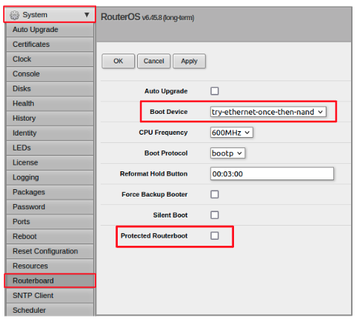

Preparation
- Download both of the appropriate Mikrotik factory and sysupgrade files from the AREDN® website. Rename the initramfs-kernel file to rb.elf and keep the sysupgrade bin file available for later.
- Set your computer’s Ethernet network adapter to a static IP address on the subnet you will be using for the new device. This can be any network number of your choice, but it is recommended that you use the 192.168.1.x subnet. Using the 192.168.1.x network on your PXE server will avoid changing IP addresses on your computer during the install process. AREDN® firmware uses the 192.168.1.x network once it is loaded, so using it all the way through the process will simplify things for you. For example, you can give your computer a static IP such as 192.168.1.10 with a netmask of 255.255.255.0. You can choose any number for the fourth octet, as long as it is not within the range of DHCP addresses you will be providing as shown below.
- Connect an Ethernet cable from your computer to the network switch, and another cable from the LAN port of the POE adapter to the switch. Finally connect an Ethernet cable from the POE port to the node, but leave the device powered off for now. If you are flashing a Mikrotik hAP ac lite that uses a separate AC adapter, connect the last Ethernet cable from the switch to the Mikrotik’s WAN port (1).

PXE Boot: Linux Procedure
- Create a directory on your computer called /tftp and copy the rb.elf file there.
- Determine your computer’s Ethernet interface name with ifconfig. It will be the interface you set to 192.168.1.10 above. You will use this interface name in the command below as the name after -i and you must substitute your login user name after -u below. Use a dhcp-range of IP addresses that are also on the same subnet as the computer: for example 192.168.1.100,192.168.1.200 as shown below.
- Open a terminal window to execute the following dnsmasq command with escalated privileges:
> sudo dnsmasq -i eth0 -u joe --log-dhcp --bootp-dynamic --dhcp-range=192.168.1.100,192.168.1.200 -d -p0 -K --dhcp-boot=rb.elf --enable-tftp --tftp-root=/tftp/
- With the unit powered off, press and hold the reset button on the radio while powering on the device. Continue to hold the reset button until you see output information from the computer window where you ran the dnsmasq command, which should happen after 20-30 seconds. Release the reset button when you see the “sent” message, which indicates success, and you can now <ctrl>-C or end dnsmasq.
- The node will now automatically reboot with the temporary AREDN® Administration image.

PXE Boot: Windows Procedure
Configure the PXE Server on your Windows computer. The example below uses Tiny PXE. For more information, see the Tools for Your Computer section above.
- Navigate to the folder where you extracted the Tiny PXE software and edit the config.ini file. Directly under the [dhcp] tag, add the following line: rfc951=1 then save and close the file.
- Copy the rb.elf file into the files folder under the Tiny PXE server directory location.
- Start the Tiny PXE server exe and select your computer’s Ethernet IP address from the dropdown list called Option 54 [DHCP Server], making sure to check the Bind IP checkbox. Under the “Boot File” section, enter rb.elf into the the Filename field, and uncheck the checkbox for “Filename if user-class = gPXE or iPXE”. Click the Online button at the top of the Tiny PXE window.
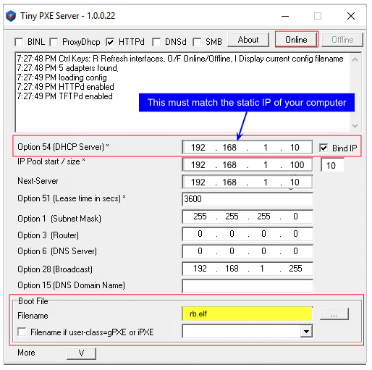
- With the unit powered off, press and hold the reset button on the node while powering on the device. Continue holding the reset button until you see TFTPd: DoReadFile: rb.elf in the Tiny PXE log window.
- Release the node’s reset button and click the Offline button in Tiny PXE. You are finished using Tiny PXE when the elf image has been read by the node.
- The node will now automatically reboot with the temporary AREDN® Administration image.

Install the sysupgrade Firmware Image
- After booting the elf image the node will have a default IP address of 192.168.1.1. Your computer should already have a static IP address on this subnet, but if not then give your computer an IP address on this subnet.
Attention
For the Mikrotik hAP ac family of devices, disconnect the Ethernet cable from the WAN port (1) on the Mikrotik and insert it into one of the LAN ports (2,3,4) before you proceed.
You should be able to ping the node at 192.168.1.1. Don’t proceed until you can ping the node. You may need to disconnect and reconnect your computer’s network cable to ensure that your IP address has been reset. Also, you may need to clear your web browser’s cache in order to remove cached pages remaining from your node’s previous firmware version.
- In a web browser, open the node’s Administration page http://192.168.1.1/cgi-bin/admin (user = ‘root’, password = ‘hsmm’) and immediately navigate to the Firmware Update section. Browse to find the sysupgrade bin file you previously downloaded and click the Upload button.
As an alternative to using the node’s web interface, you can manually copy the sysupgrade bin file to the node and run a command line program to install the firmware. This will allow you to see any error messages that may not appear when using the web interface. Note that devices running AREDN® firmware images use port 2222 for secure copy/shell access.
Execute the following commands from a Linux computer:
my-computer:$ scp -P 2222 <aredn-firmware-filename>.bin root@192.168.1.1:/tmp
my-computer:$ ssh -p 2222 root@192.168.1.1
~~~~~~~ after logging into the node with ssh ~~~~~~~
node:# sysupgrade -n /tmp/<aredn-firmware-filename>.bin
To transfer the image from a Windows computer you can use a Secure Copy program such as WinSCP. Then use a terminal program such as PuTTY to connect to the node via ssh or telnet in order to run the sysupgrade command shown as the last line above.
- The node will now automatically reboot with the new AREDN® firmware image.

Installing AREDN® Firmware — AREDN Documentation Latest Nightly Build documentation (arednmesh.org)

