EDUP 4W Wifi Amplifier
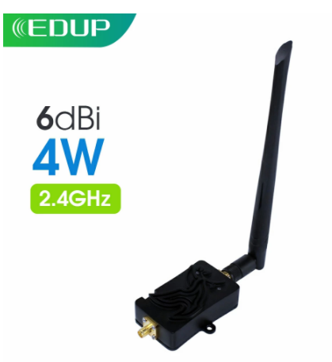
Notes:
Your device must be SMA antenna detachable Connector when used it , for example SMA detachable antenna router
Please confirm that you device output power range is between 3dBm and 20dBm, only that the wifi signal booster could work well

Features:
Low-noise receive gain
Signal activity LED indicates
High Gain, High Value, High Performance
Maximum output power of 4000mW by the Booster
Plug-and-play, Easy installation, no driver needed
Ideal for increase the 2400-2500Mhz frequency devices
Increase the effective range and coverage area of your Wi-Fi network
Simply attach the booster in between the standard antenna on a wireless router or wireless access point and watch your range grow
The amplified wireless signal may even penetrate complex environments with many walls and obstacles
Ideal for use with 2.4GHz Wireless LANs, Support 802.11b, 802.11g, 802.11n (2.4Ghz mode only)

Specification:
Operation Range: 2400-2500 MHz.
Operation Mode: Bi-directional, half-duplex, Auto-Switching via carrier sensing.
Frequency Response: ± 1dB over operation range.
Input Power: 3dBm (Min.) - 20dBm (Max.)
Output Power: 4000mW nominal (36dBm )
Transmit Gain: 12-14dBm nominal
Receiver Gain: 9-11dBm.
Receive Noise Figure: 3.0dBm nominal.
Operating Temperature: -40 to 70 degree.
Operating Humidity: Up to 95% relative humidity.
Material: Cast Aluminum
Dimension: 82x50x21mm
Weight: 0.25kg net

Package Content:
1 x WiFi Booster
1 x Power Adapter (12vDC, 1A)
1x 20cm RG316 Cable,
1x 5dBi Antenna
1 x English User Manual



