ÄRTEN™ MESH Node v2021
Equipment List
15 March 2023

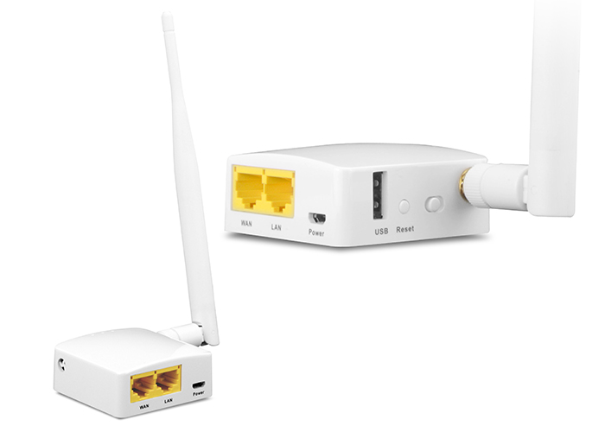

GL·iNet GL-AR150-Ext with External Antenna from Fruugo $64.00
Ar150 Mini Travel Router Wifi Converter | Fruugo US

EDUP 2.4Ghz 4 Watt WiFi Booster from AliExpress

High Gain 10dB 2.4Ghz Yagi antenna (a.k.a. 2.4G WiFi Directional Video Transmission Antenna) from AliExpress

SMA Connector/Adapter Assortment from AliExpress

